


MEDIA ARCHIVE

Erol Çelik
2022510164

2024/2025 FALL
CME 2201- Assingment 1
Dr. Feriştah DALKILIÇ

>Introduction
Efficient data management is one of the cornerstones of modern computing, and in this project, a hashed dictionary shall be employed in implementing a media archive management system. The system can be used by users to store, retrieve, and manage media items such as movies, TV shows, and many others in an organized and efficient manner.

Therefore, the key challenge in managing large-scale media data is how to access the data quickly and reduce the overhead of storage. Hash tables ensure a constant average-time complexity of insertions, removals, and lookups. Thus, with carefully chosen hash functions and an efficient handling policy against hash collisions, this project will develop an optimized architecture concerning storing and retrieving in highly loaded conditions.

In this project, a hash table is to be populated from a CSV-based media dataset. Support functions include adding of media entries, searching by title, and listing of media by categories. The enhancement of performance using techniques like double hashing and dynamic resizing can be assured so that the dictionary remains efficient as the dataset grows.

The report discusses the design and implementation of the Hashed Dictionary, describing methodologies, algorithms, and design decisions made while implementing it. Performance analysis was also done to assess how the system performs under a variety of scenarios.

>Data Structures

Interfaces
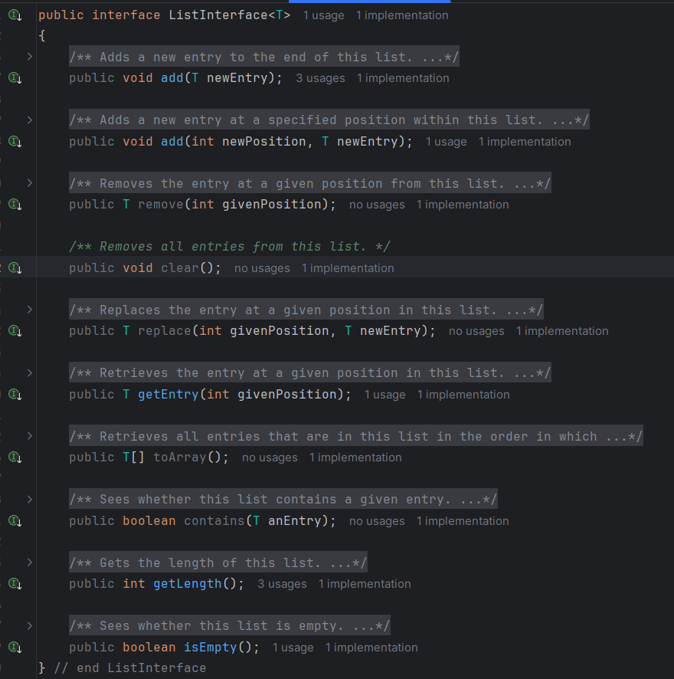
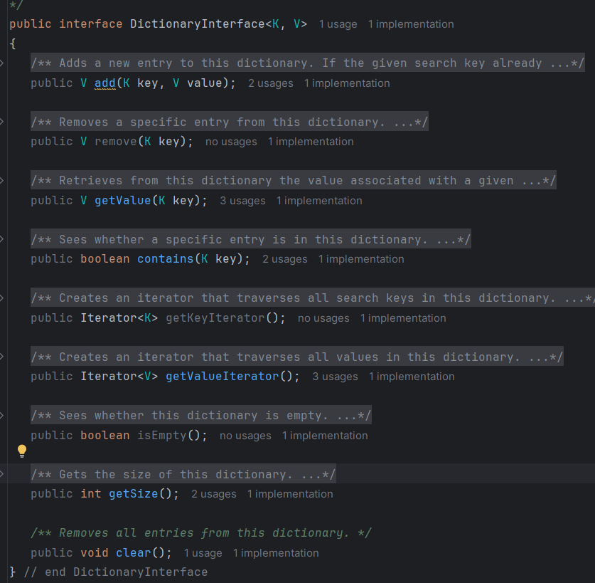
The interfaces DictionaryInterface and ListInterface are defined to ensure consistency and modularity. These interfaces provide abstraction by well-defined methods for adding, removing, and accessing elements and flexibility by makes it easy to extend or integrate other data structures when needed.
Media Class
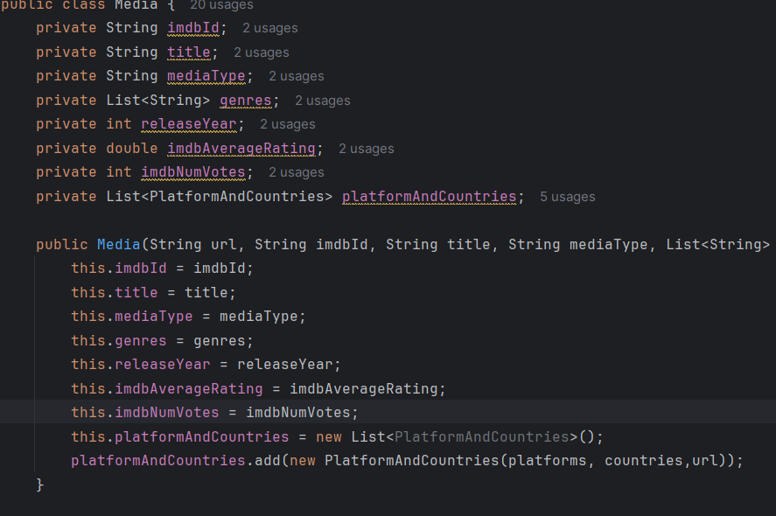
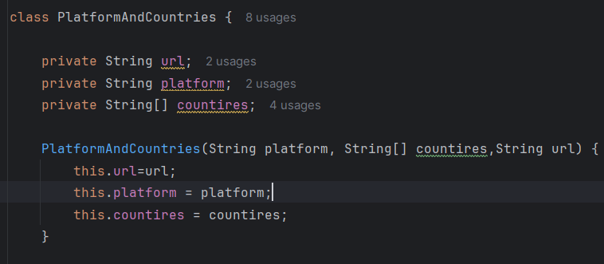
The Media class is a custom data structure designed to encapsulate all relevant information about a media item. It contains an inner class to hold platform-country buckets.

Hash Table (HashedDictionary)
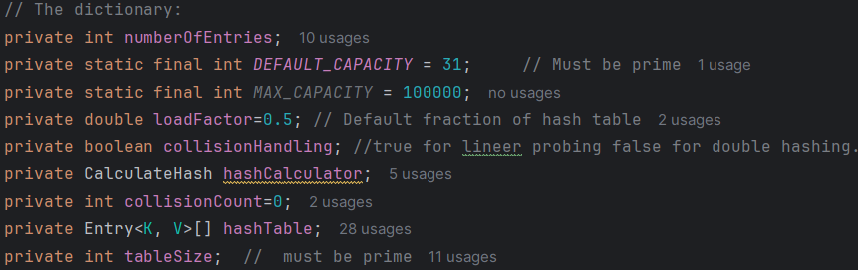
The heart of the system is the hash table implemented with the class HashedDictionary; the hash table allows for constant-time complexity in the best case for inserting, removing, and looking up items. For this project, the keys are media titles, while the values are objects representing the media with the genre, platform, and IMDb rating.
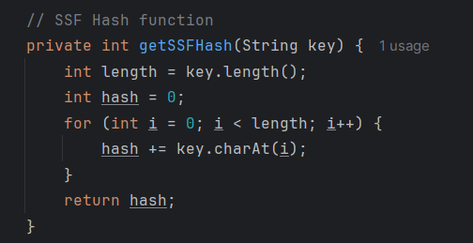
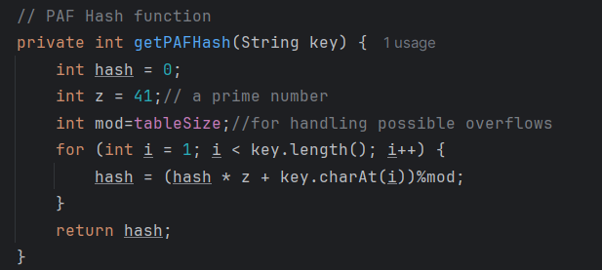
There are two types of hash funciton.1- SSF- Simple Summation Function: Computed as the ASCII sum of characters in the key.2- PAF- Polynomial Accumulation Function: employs a polynomial formula for the better distribution of keys.

Collision Handling: Two different methods have been employed in order to handle collisions in the slots of the hash table.1- Linear Probing: It searches for the next available slot in the table.2- Double Hashing: Using a second hash function to determine the step sizes during probing.
Dynamic resizing: to maintain efficiency during execution, if the load factor exceeds a certain threshold, the hash table resizes itself.

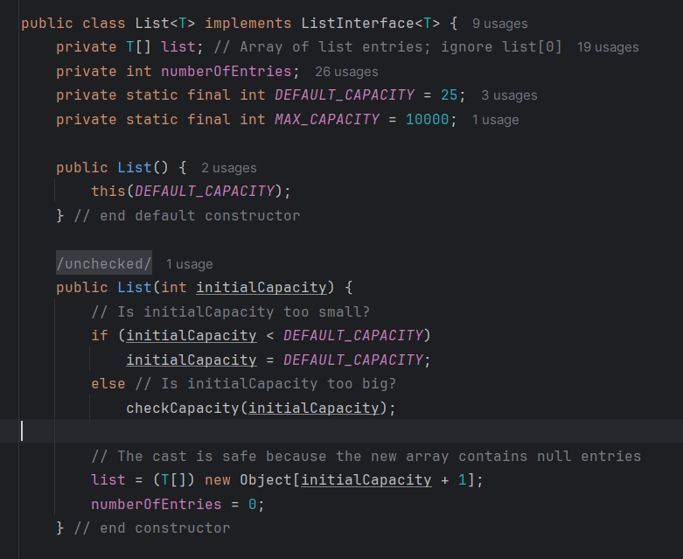
List

A list structure is used hold Countreis
It has own Add, Remove,Contains and other required methods.

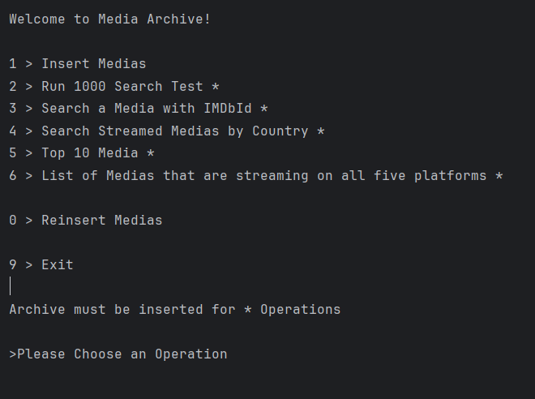
Menu

>Implementions

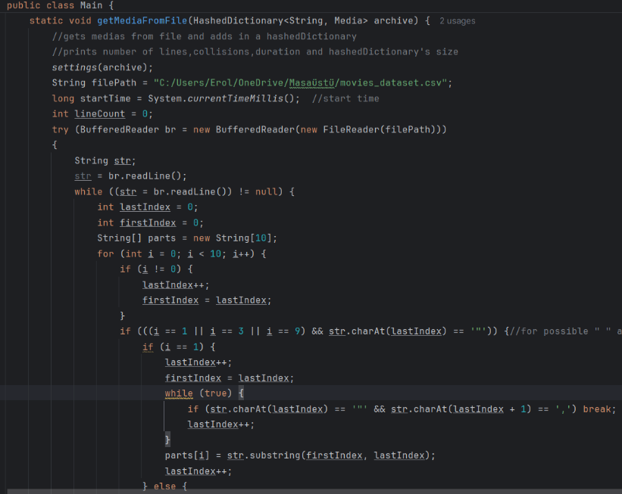
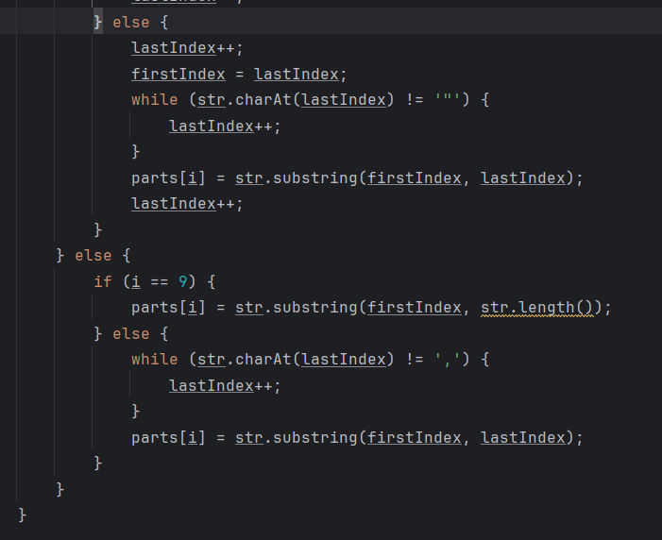
Getting Media from the csv file method has two parts. 1- Reading and splitting to parts.2 – Creating a new Media object with those parts.
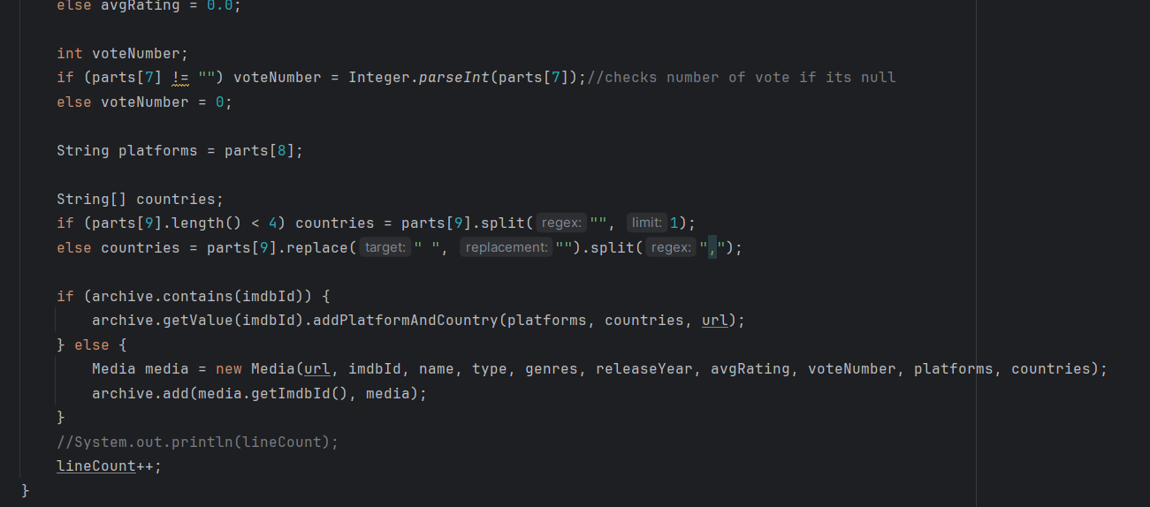
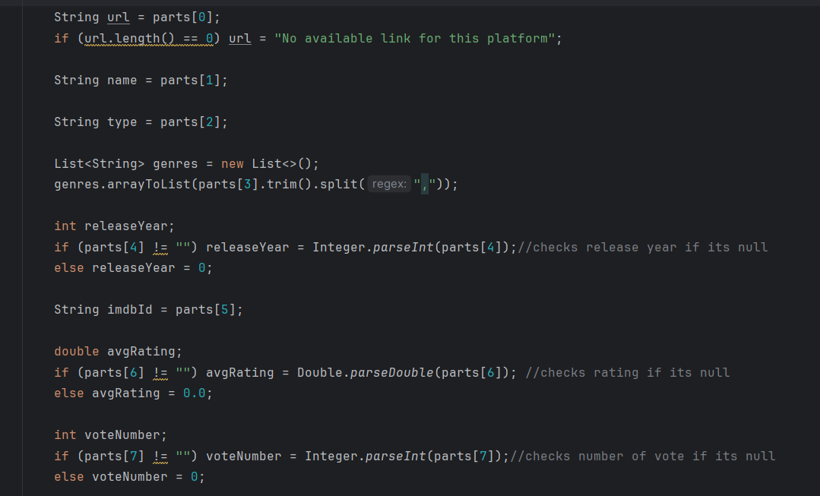
Reading and splitting parts by regex.
Creating the media. If media exist just updates platforms and countires.

Prints archive size , inserting time and number of medias after reading process.

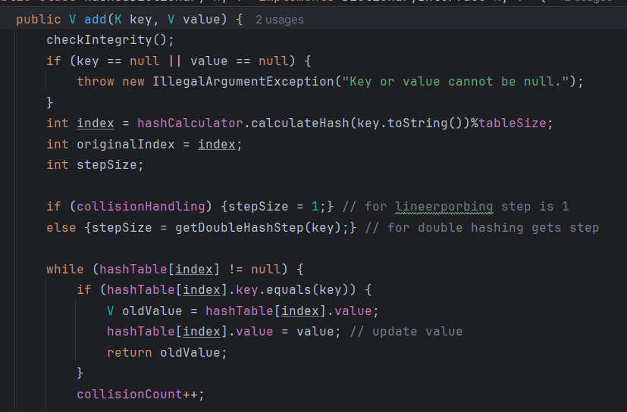
Hashed Dictionary Add Method
The `add` method efficiently places the key-value pairs inside the hash table by sorting collisions and maintaining good performance. It starts by checking inputs and calculating the index by means of a hash function. It then resolves the collision-if there is one-either by linear probing, wherein it goes sequentially to the next index, or by double hashing, wherein it utilizes a secondary hash function to determine the step size.
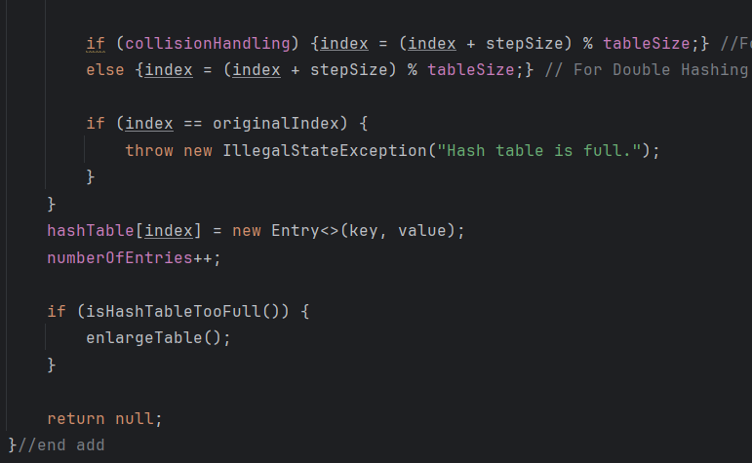
If the key already exists, then the value is updated. For new entries, the method goes ahead to find an empty slot where it can insert the key-value pair. In case the table's load factor is exceeded, it dynamically resizes the table for efficiency. If the table is full and no slot is found, then an exception is thrown. This approach balances the use of the fastest operations, effective collision handling, and dynamic resizing for consistent performance.

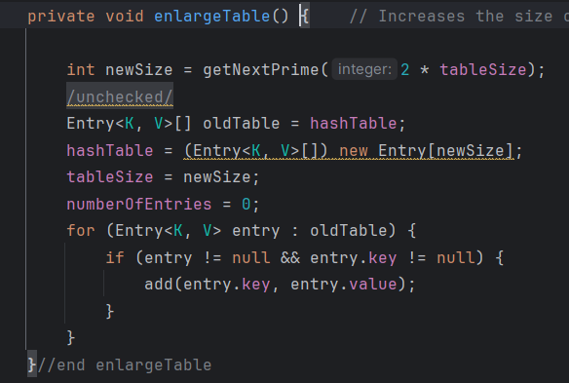
Remove and getValue methods operate similarly to the add method, using hash functions to locate the initial index and handling collisions through linear probing or double hashing.
In remove, once the key is found, the entry is deleted, and the table's structure is adjusted to maintain proper functionality. In getValue, the method searches for the key and retrieves its value, navigating collisions as needed. Both methods ensure fast and reliable operations by leveraging the hash table's design and collision resolution strategies.

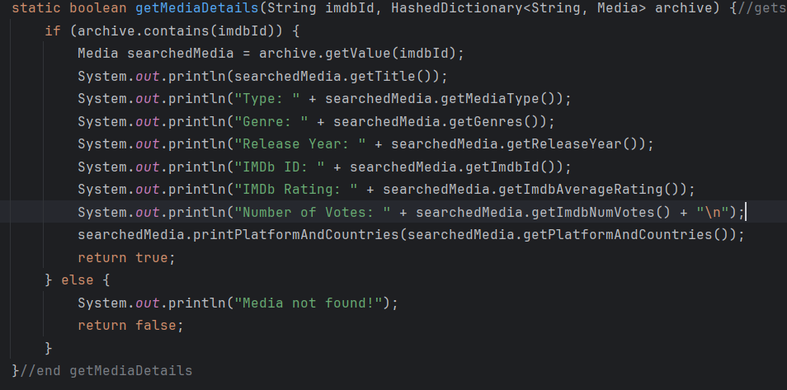
Get Media Details
Retrieves and displays the detailed information of a specific media item based on its key. It uses the hash table’s getValue functionality to locate the corresponding entry efficiently. If the media is found, its attributes, such as title, genre, platform, and IMDb rating, are returned. This method ensures quick access to media details, leveraging the hash table's optimized search capabilities.
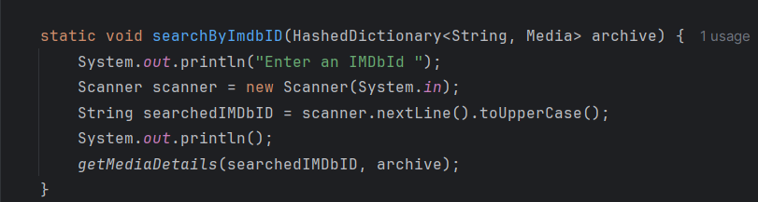
SearchByImdbId gets a media id by user and calls getMediaDetails.

Menu gets a number(as operation) from user and calls related methods.
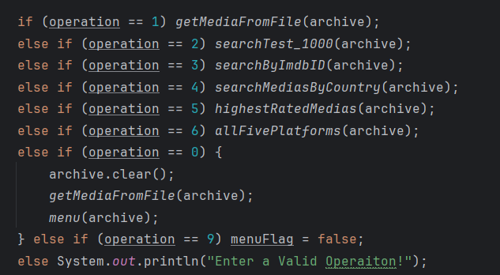
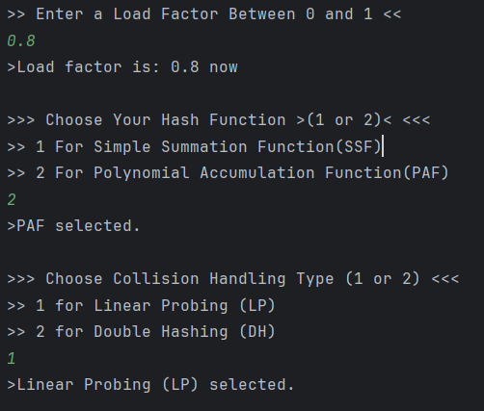
;
Also you can set your Settings.
Getter/Setter methods and scanner operations are used for those.

Searching Methods with Iterator
The searchMediasByCountry method looks for all the media available in a given country by iterating through the table and checking the associated country information for each media entry. Similarly, the allFivePlatforms method will look into the hash table for media across all five supported platforms to ensure complete platform compatibility. Finally, the method highestRatedMedias will scan all entries in search of the media with the highest IMDb ratings, returning those of topmost quality in the dataset. All these methods use the iterator for straightforward and flexible searches; hence, they guarantee results that are accurate and fast for various queries that a user may have.
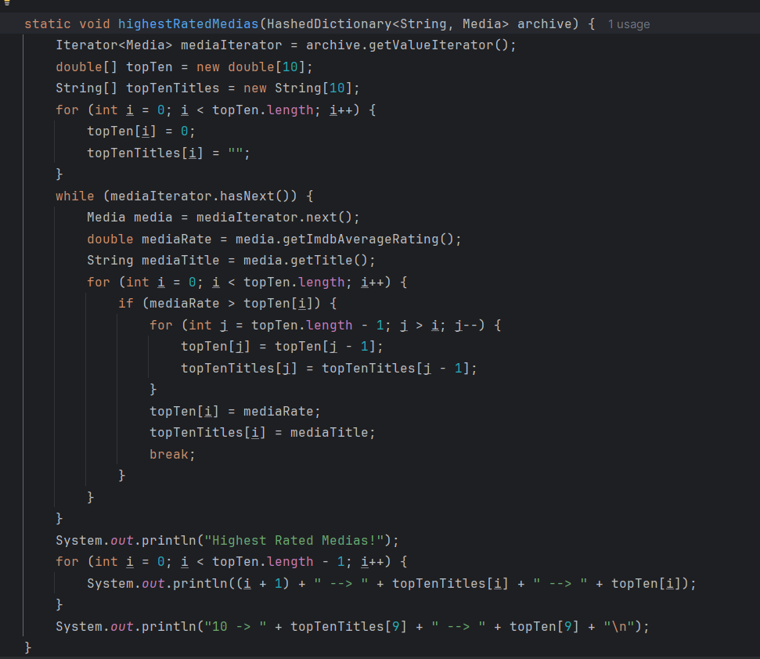
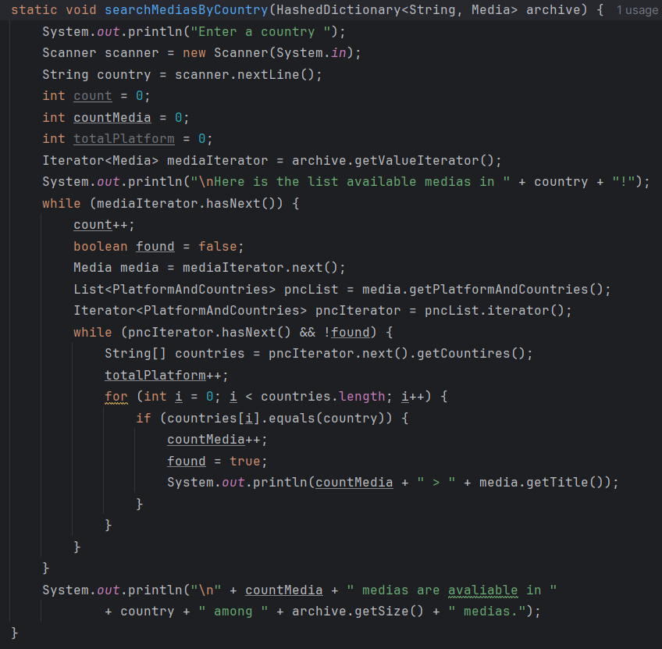
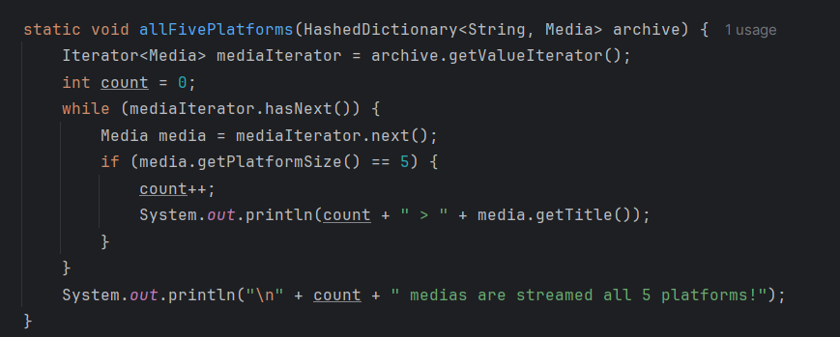

>Performance Table
Load Factor | Hash Function | Collision Handling | Collision Count | Indexing Time (ms) | Avg. Search Time (ms)
α=50% | SSF | LP | 1906734568 | 233307 | 2.403
α=50% | SSF | DH | 204492901 | 135593 | 5.164
α=50% | PAF | LP | 93591 | 651 | 0.092
α=50% | PAF | DH | 122294 | 860 | 0.095
α=80% | SSF | LP | 672255915 | 195445 | 2.314
α=80% | SSF | DH | 190713298 | 128894 | 1.663
α=80% | PAF | LP | 315113 | 557 | 0.084
α=80% | PAF | DH | 240233 | 747 | 0.200

